Oak & Ember Informational Website
Project 03 | Development plan

Project Goal: We'll build Oak & Ember as a fictional premium restaurant and café website, taking inspiration from The Ivy Collection—particularly its long, visually rich homepage, elegant presentation, and restaurant-focused navigation.
Our version will have its own identity, using deep forest green, sage, ivory, and subtle gold accents.
Project Overview
Item | Description
Project Name | Oak and Ember
Business type | Restaurant & Café
Website type | Multi page informational website
Pages | 6
Technology | HTML, CSS, JavaScript
Design | Premium, Warm, Elegant, Responsive
Main Purpose | Menu. Opening hours, announcements, reservations, gallery, contact, careers
Payment Integration | None
E-commerce | Not Included
Deployment | GitHub Pages / Cloudflare Pages
Database | Not Required

Primary objectives: Allow customers to explore the restaurant, view the menu, discover signature dishes, check announcements and opening hours, request table reservations, and learn about career opportunities.
Color Usage
- Forest Green #183C32
- Moss Green #416653
- Sage #A8B8A0
- Ivory #F7F5ED
- Muted Gold #C5A46D
- Dark Charcoal #252B26
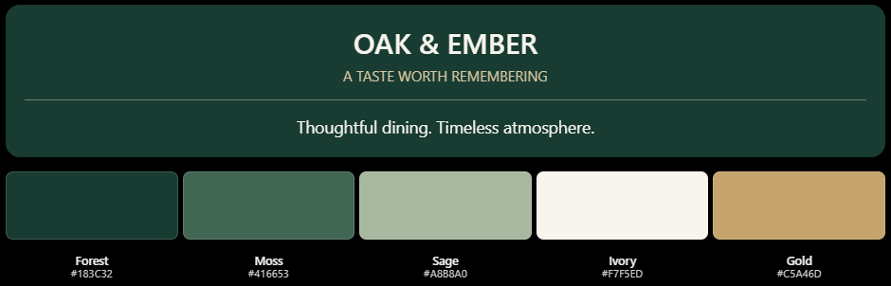

1. Website Sections and Features
Home Page – Detailed Plan
- Announcement bar + Navigation – Our story, Full Menu, Gallery, Reserve table
- Full-width hero carousel
- Welcome to Oak & Ember - CTA: Discover Our Story
- Our Signature Dishes - CTA: Explore Full Menu
- Seasonal Specials & Announcements
- The Dining Experience - CTA: View Gallery, Enquire now (email inquiry)
- Guest Testimonials
Other pages
About us. - Restaurant story, culinary philosophy, sourcing and ingredients, atmosphere, chef introduction, and a reservation CTA.
Our Menu - Filterable menu categories: Breakfast, Lunch, Dinner, Desserts, and Beverages. Each dish includes a name, description, price, and relevant dietary information. Signature dishes receive special emphasis.
Gallery - Responsive image grid featuring food, interiors, drinks, and events, with category filters and a lightbox.
Reservation - Customer name, email, phone, preferred date, time, party size, and special requests. Form validation, acknowledgement, and email notification to the owner.
Careers - Introduction to working at Oak & Ember, employee culture, benefits, current vacancies, job requirements, and application instructions.

2. Reservation Functionality
Request-and-confirm model will be used.
- Customer chooses preferred date, time, and number of guests.
- Customer submits the reservation request.
- A form service securely forwards the request to the restaurant owner's email.
- The customer receives an acknowledgement, if configured.
- The owner checks table availability and replies with a confirmation or alternative.
3. Shared footer
Every page will have the same footer.
4. Development Phases
Phase 1: Project setup and design system
Create folders, set colors, fonts, shared components.
Phase 2: Homepage development
Build the carousel and all homepage sections.
Phase 3: Internal pages
Build About, Menu, Gallery, Reservations, Careers.
Phase 4: JavaScript functionality
Implement menu filtering, gallery, navigation and forms.
Phase 5: Responsive design and testing
Test mobile layouts, accessibility and performance.
Phase 6: Deployment and portfolio
Publish on GitHub Pages and add to portfolio/Fiverr.

Out of scope
The project will not include e-commerce functionality, online payments, user authentication, database integration, real-time table availability, or an admin dashboard. Ongoing website maintenance and advanced reservation management are also excluded.
Final deliverable
The project will deliver a fully functional, responsive six-page restaurant website developed using HTML, CSS, and JavaScript. It will include interactive features, an email-based reservation request form, complete source code, and a live deployed website.

